Deep Fake Detection for images and video

### Team: Starks

### Reporting Period: February, 2023

**I. Feature Development Updates:**

1. Data Collection: Successfully acquired a Deepfake dataset containing adequate real and fake videos
2. Model Training: Built and trained a neural network for aggregating the probability from individual model to form a single probability score for the video being deepfake. The aggregate model was prepared on historic data. The results show an accuracy of more than 75% on the validation set. Currently experimenting with hyperparameter tuning to improve accuracy and explore other potential model architectures.
3. API Development: Developed FastAPI endpoints using Python to receive new videos and return deepfake detection. Completed basic functionality for single upload and providing the probability of models depicting the video to be deepfake
4. Frontend Development: Created a basic front-end prototype using React for visualizing deepfake detection results. Currently displaying the graphs and aggregate function score.

**II. AI Model Training and Results:**

1. Evaluation Metrics:

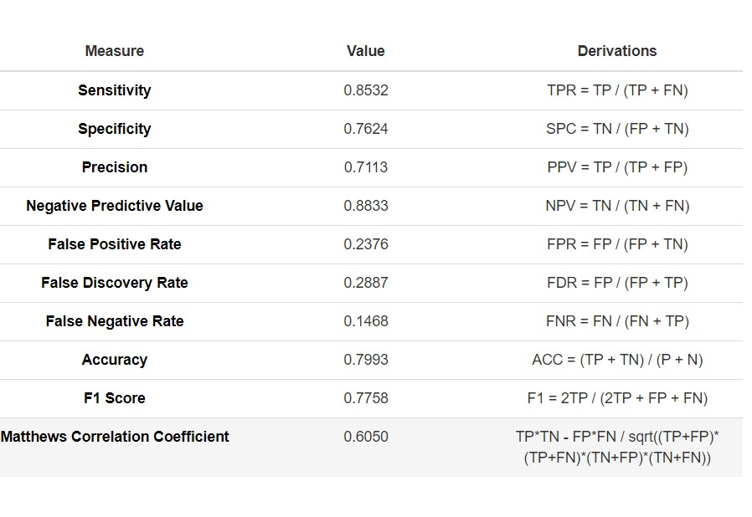

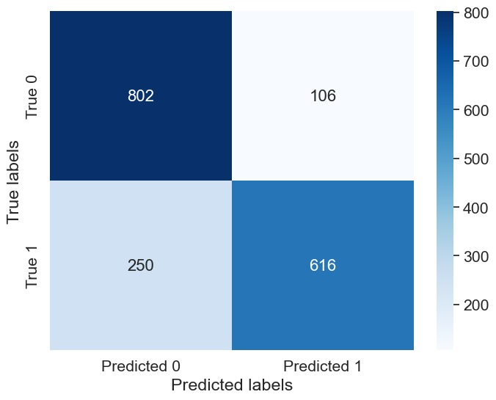

1. Data Augmentation: A well balanced dataset, with adequate real and fake labels, for training the aggregate model.

**III. Basic Frontend:**

1. Current Features: Displays the detection analysis with the help of graphs (Matplotlib in the backend) and confidence aggregate probability of deepfake. Allows user to select detectors for the detection
2. Planned Features: Interactive visualizations for the deepfake detection, how each model proves to give a precise detection and probability score. User can also view the uploaded video.